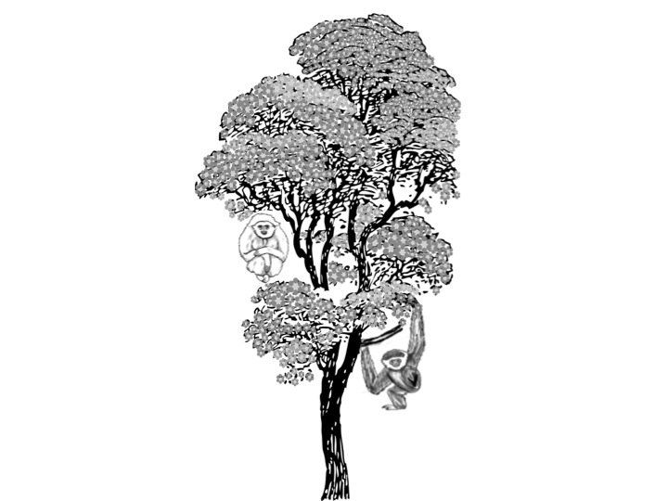

Draw what actions you will take to help save gibbons

Join My Pledge

To Save Gibbons