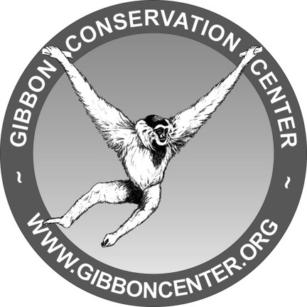

Date:__________________________

The Gibbon Pledge

I____________________________________Pledge to help conserve the rainforest for gibbons and other plants and animals. I will do my part by:

1. Recycling, Reducing, Reusing

2. Avoiding Palm Oil

3.Sharing what I’ve learned

Date:__________________________

The Gibbon Pledge

I____________________________________Pledge to help conserve the rainforest for gibbons and other plants and animals. I will do my part by:

1. Recycling, Reducing, Reusing

2. Avoiding Palm Oil

3.Sharing what I’ve learned

Date:__________________________

The Gibbon Pledge

I____________________________________Pledge to help conserve the rainforest for gibbons and other plants and animals. I will do my part by:

1. Recycling, Reducing, Reusing

2. Avoiding Palm Oil

3.Sharing what I’ve learned

Date:__________________________

The Gibbon Pledge

I____________________________________Pledge to help conserve the rainforest for gibbons and other plants and animals. I will do my part by:

1. Recycling, Reducing, Reusing

2. Avoiding Palm Oil

3.Sharing what I’ve learned